  The Power of Possible  The Power of Possible (POP) prepares jobseekers to become an asset in the workplace and to begin on a path of individual economic wellbeing.  What is the Power of Possible?  This is a dynamic and innovative program that includes skills for job seeking, self-management tools, and a structured, active job search curriculum. The training includes various hours of instruction and time management activities, ensuring jobseekers arrive at the workplace equipped to work effectively in whichever areas their employer requires.  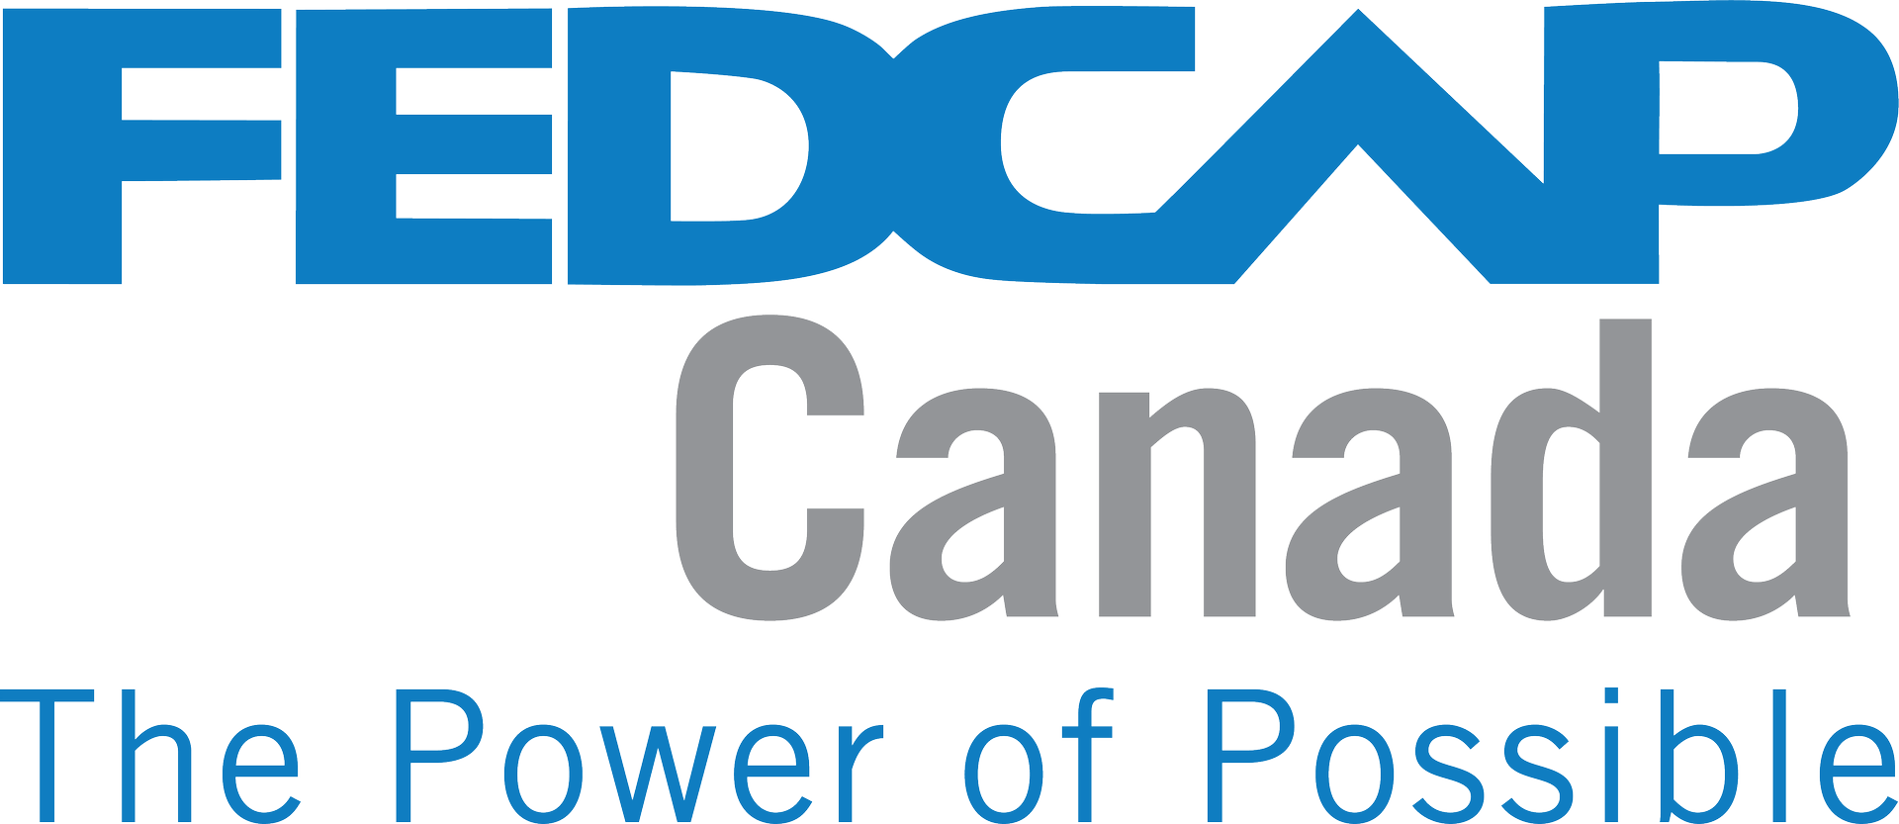   | This Program Will Teach You About:  Interview Practice  Job Leads & Networking Opportunities  Resume Development  Money Management Tips  Goal Setting Techniques  Contacts:  905-732-7655  905-871-3932  mbulters@jhs-niagara.ca

